What is 2D Transformation in Computer Graphics?
2D Transformation in computer graphics is a process of modifying and re-positioning the existing graphics in 2 dimensions. Transformations help change the object's position, size, orientation, shape, etc.; there are three basic rigid transformations: reflections, rotations, and translations. 2D Transformations in computer graphics take place in a two-dimensional plane. There is a fourth common transformation called dilation.
In this article, we will learn about the transformation in computer graphics, various types of transformation, and their examples.
Transformation means a change in the object's orientation, size, and shape. They position the object, change its shape, and even change how something is viewed. Transformation plays a major role in computer graphics, repositioning the graphics on the screen and changing their size or orientation. The basic geometrical 2D Transformation in Computer Graphics are:
- Translation
- Rotation
- Scaling
The derived geometrical transformation is:
- Reflection
- Shearing

Signup for Free Mock Test

2D Transformation in Computer Graphics-

Transformation Techniques-

In computer graphics, various transformation techniques are-

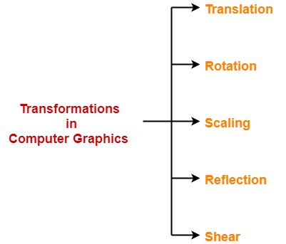

- Translation
- Rotation
- Scaling
- Reflection
- Shear

In this article, we will discuss about 2D Translation in Computer Graphics.

2D Translation in Computer Graphics-

In Computer graphics,
2D Translation is a process of moving an object from one position to another in a two dimensional plane.

Consider a point object O has to be moved from one position to another in a 2D plane.

Let-
- Initial coordinates of the object O = (X_{old}, Y_{old})
- New coordinates of the object O after translation = (X_{new}, Y_{new})
- Translation vector or Shift vector = (T_{x}, T_{y})

Given a Translation vector (T_{x}, T_{y})-
- T_{x} defines the distance the X_{old} coordinate has to be moved.
- T_{y} defines the distance the Y_{old} coordinate has to be moved.

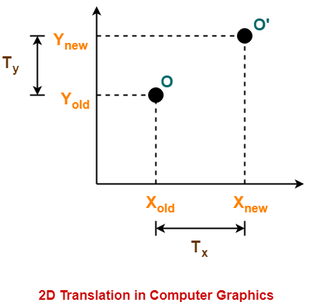

This translation is achieved by adding the translation coordinates to the old coordinates of the object as-
- X_{new} = X_{old} + T_{x} (This denotes translation towards X axis)
- Y_{new} = Y_{old} + T_{y} (This denotes translation towards Y axis)

In Matrix form, the above translation equations may be represented as-

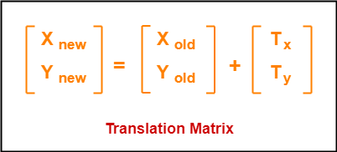

- The homogeneous coordinates representation of (X, Y) is (X, Y, 1).
- Through this representation, all the transformations can be performed using matrix / vector multiplications.

The above translation matrix may be represented as a 3 x 3 matrix as-

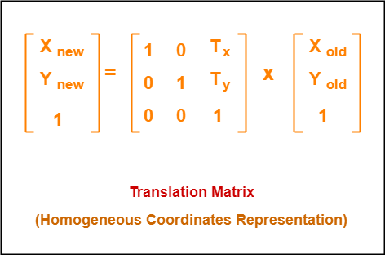

PRACTICE PROBLEMS BASED ON 2D TRANSLATION IN COMPUTER GRAPHICS-

Problem-01:

Given a circle C with radius 10 and center coordinates (1, 4). Apply the translation with distance 5 towards X axis and 1 towards Y axis. Obtain the new coordinates of C without changing its radius.

Solution-

Given-
- Old center coordinates of C = (X_{old}, Y_{old}) = (1, 4)
- Translation vector = (T_{x}, T_{y}) = (5, 1)

Let the new center coordinates of C = (X_{new}, Y_{new}).

Applying the translation equations, we have-
- X_{new} = X_{old} + T_{x} = 1 + 5 = 6
- Y_{new} = Y_{old} + T_{y} = 4 + 1 = 5

Thus, New center coordinates of C = (6, 5).

Alternatively,

In matrix form, the new center coordinates of C after translation may be obtained as-

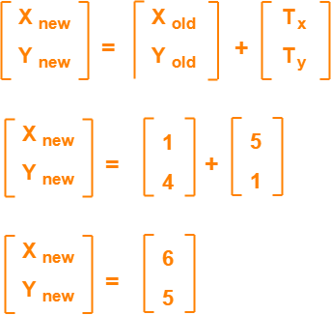

Thus, New center coordinates of C = (6, 5).

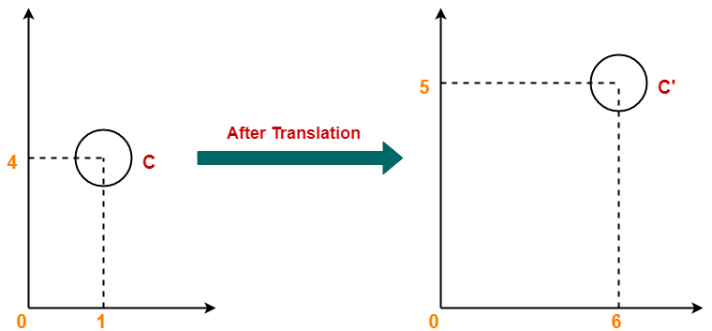

Problem-02:

Given a square with coordinate points A(0, 3), B(3, 3), C(3, 0), D(0, 0). Apply the translation with distance 1 towards X axis and 1 towards Y axis. Obtain the new coordinates of the square.

Solution-

Given-
- Old coordinates of the square = A (0, 3), B(3, 3), C(3, 0), D(0, 0)
- Translation vector = (T_{x}, T_{y}) = (1, 1)

For Coordinates A(0, 3)

Let the new coordinates of corner A = (X_{new}, Y_{new}).

Applying the translation equations, we have-
- X_{new} = X_{old} + T_{x} = 0 + 1 = 1
- Y_{new} = Y_{old} + T_{y} = 3 + 1 = 4

Thus, New coordinates of corner A = (1, 4).

For Coordinates B(3, 3)

Let the new coordinates of corner B = (X_{new}, Y_{new}).

Applying the translation equations, we have-
- X_{new} = X_{old} + T_{x} = 3 + 1 = 4
- Y_{new} = Y_{old} + T_{y} = 3 + 1 = 4

Thus, New coordinates of corner B = (4, 4).

For Coordinates C(3, 0)

Let the new coordinates of corner C = (X_{new}, Y_{new}).

Applying the translation equations, we have-
- X_{new} = X_{old} + T_{x} = 3 + 1 = 4
- Y_{new} = Y_{old} + T_{y} = 0 + 1 = 1

Thus, New coordinates of corner C = (4, 1).

For Coordinates D(0, 0)

Let the new coordinates of corner D = (X_{new}, Y_{new}).

Applying the translation equations, we have-
- X_{new} = X_{old} + T_{x} = 0 + 1 = 1
- Y_{new} = Y_{old} + T_{y} = 0 + 1 = 1

Thus, New coordinates of corner D = (1, 1).
Thus, New coordinates of the square = A (1, 4), B(4, 4), C(4, 1), D(1, 1).

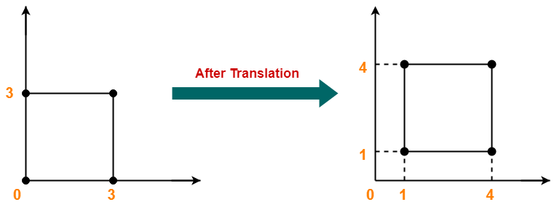

2D Rotation in Computer Graphics-

In Computer graphics,
2D Rotation is a process of rotating an object with respect to an angle in a two dimensional plane.

Consider a point object O has to be rotated from one angle to another in a 2D plane.

Let-
- Initial coordinates of the object O = (X_{old}, Y_{old})
- Initial angle of the object O with respect to origin = Φ
- Rotation angle = θ
- New coordinates of the object O after rotation = (X_{new}, Y_{new})

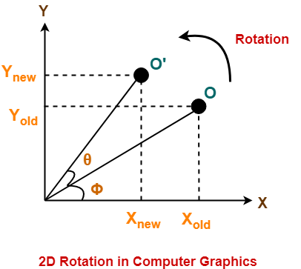

This rotation is achieved by using the following rotation equations-
- X_{new} = X_{old} x cosθ – Y_{old} x sinθ
- Y_{new} = X_{old} x sinθ + Y_{old} x cosθ

In Matrix form, the above rotation equations may be represented as-

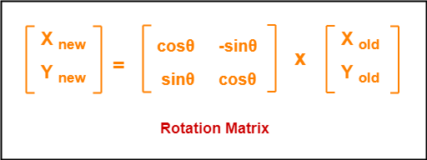

For homogeneous coordinates, the above rotation matrix may be represented as a 3 x 3 matrix as-

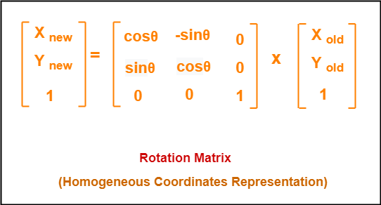

PRACTICE PROBLEMS BASED ON 2D ROTATION IN COMPUTER GRAPHICS-

Problem-01:

Given a line segment with starting point as (0, 0) and ending point as (4, 4). Apply 30 degree rotation anticlockwise direction on the line segment and find out the new coordinates of the line.

Solution-

We rotate a straight line by its end points with the same angle. Then, we re-draw a line between the new end points.

Given-
- Old ending coordinates of the line = (X_{old}, Y_{old}) = (4, 4)
- Rotation angle = θ = 30º

Let new ending coordinates of the line after rotation = (X_{new}, Y_{new}).

Applying the rotation equations, we have-

X_{new}
= X_{old} x cosθ – Y_{old} x sinθ
= 4 x cos30º – 4 x sin30º
= 4 x (√3 / 2) – 4 x (1 / 2)
= 2√3 – 2
= 2(√3 – 1)
= 2(1.73 – 1)
= 1.46

Y_{new}
= X_{old} x sinθ + Y_{old} x cosθ
= 4 x sin30º + 4 x cos30º
= 4 x (1 / 2) + 4 x (√3 / 2)
= 2 + 2√3
= 2(1 + √3)
= 2(1 + 1.73)
= 5.46

Thus, New ending coordinates of the line after rotation = (1.46, 5.46).

Alternatively,

In matrix form, the new ending coordinates of the line after rotation may be obtained as-

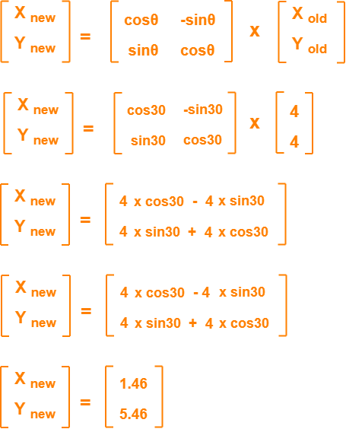

Thus, New ending coordinates of the line after rotation = (1.46, 5.46).

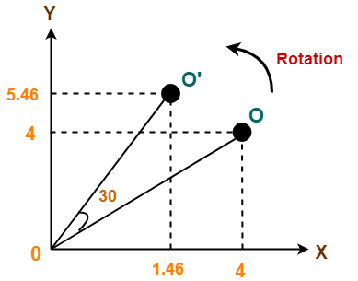

Problem-02:

Given a triangle with corner coordinates (0, 0), (1, 0) and (1, 1). Rotate the triangle by 90 degree anticlockwise direction and find out the new coordinates.

Solution-

We rotate a polygon by rotating each vertex of it with the same rotation angle.

Given-
- Old corner coordinates of the triangle = A (0, 0), B(1, 0), C(1, 1)
- Rotation angle = θ = 90º

For Coordinates A(0, 0)

Let the new coordinates of corner A after rotation = (X_{new}, Y_{new}).

Applying the rotation equations, we have-

X_{new}
= X_{old} x cosθ – Y_{old} x sinθ
= 0 x cos90º – 0 x sin90º
= 0

Y_{new}
= X_{old} x sinθ + Y_{old} x cosθ
= 0 x sin90º + 0 x cos90º
= 0

Thus, New coordinates of corner A after rotation = (0, 0).

For Coordinates B(1, 0)

Let the new coordinates of corner B after rotation = (X_{new}, Y_{new}).

X_{new}
= X_{old} x cosθ – Y_{old} x sinθ
= 1 x cos90º – 0 x sin90º
= 0

Y_{new}
= X_{old} x sinθ + Y_{old} x cosθ
= 1 x sin90º + 0 x cos90º
= 1 + 0
= 1

Thus, New coordinates of corner B after rotation = (0, 1).

For Coordinates C(1, 1)

Let the new coordinates of corner C after rotation = (X_{new}, Y_{new}).

X_{new}
= X_{old} x cosθ – Y_{old} x sinθ
= 1 x cos90º – 1 x sin90º
= 0 – 1
= -1

Y_{new}
= X_{old} x sinθ + Y_{old} x cosθ
= 1 x sin90º + 1 x cos90º
= 1 + 0
= 1

Thus, New coordinates of corner C after rotation = (-1, 1).

Thus, New coordinates of the triangle after rotation = A (0, 0), B(0, 1), C(-1, 1).

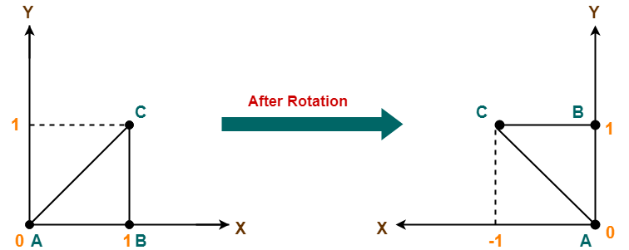

2D Scaling in Computer Graphics-

In computer graphics, scaling is a process of modifying or altering the size of objects.

- Scaling may be used to increase or reduce the size of object.
- Scaling subjects the coordinate points of the original object to change.
- Scaling factor determines whether the object size is to be increased or reduced.
- If scaling factor > 1, then the object size is increased.
- If scaling factor < 1, then the object size is reduced.

Consider a point object O has to be scaled in a 2D plane.

Let-
- Initial coordinates of the object O = (X_{old}, Y_{old})
- Scaling factor for X-axis = S_{x}
- Scaling factor for Y-axis = S_{y}
- New coordinates of the object O after scaling = (X_{new}, Y_{new})

This scaling is achieved by using the following scaling equations-
- X_{new} = X_{old} x S_{x}
- Y_{new} = Y_{old} x S_{y}

In Matrix form, the above scaling equations may be represented as-

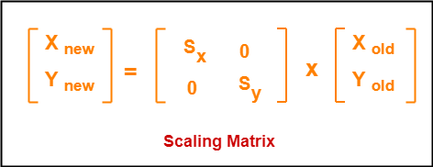

For homogeneous coordinates, the above scaling matrix may be represented as a 3 x 3 matrix as-

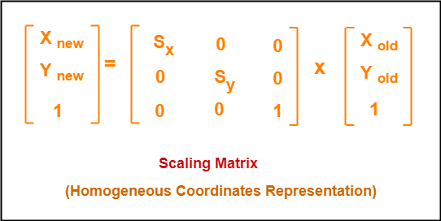

PRACTICE PROBLEMS BASED ON 2D SCALING IN COMPUTER GRAPHICS-

Problem-01:

Given a square object with coordinate points A(0, 3), B(3, 3), C(3, 0), D(0, 0). Apply the scaling parameter 2 towards X axis and 3 towards Y axis and obtain the new coordinates of the object.

Solution-

Given-
- Old corner coordinates of the square = A (0, 3), B(3, 3), C(3, 0), D(0, 0)
- Scaling factor along X axis = 2
- Scaling factor along Y axis = 3

For Coordinates A(0, 3)

Let the new coordinates of corner A after scaling = (X_{new}, Y_{new}).

Applying the scaling equations, we have-
- X_{new} = X_{old} x S_{x} = 0 x 2 = 0
- Y_{new} = Y_{old} x S_{y} = 3 x 3 = 9

Thus, New coordinates of corner A after scaling = (0, 9).

For Coordinates B(3, 3)

Let the new coordinates of corner B after scaling = (X_{new}, Y_{new}).

Applying the scaling equations, we have-
- X_{new} = X_{old} x S_{x} = 3 x 2 = 6
- Y_{new} = Y_{old} x S_{y} = 3 x 3 = 9

Thus, New coordinates of corner B after scaling = (6, 9).

For Coordinates C(3, 0)

Let the new coordinates of corner C after scaling = (X_{new}, Y_{new}).

Applying the scaling equations, we have-
- X_{new} = X_{old} x S_{x} = 3 x 2 = 6
- Y_{new} = Y_{old} x S_{y} = 0 x 3 = 0

Thus, New coordinates of corner C after scaling = (6, 0).

For Coordinates D(0, 0)

Let the new coordinates of corner D after scaling = (X_{new}, Y_{new}).

Applying the scaling equations, we have-
- X_{new} = X_{old} x S_{x} = 0 x 2 = 0
- Y_{new} = Y_{old} x S_{y} = 0 x 3 = 0

Thus, New coordinates of corner D after scaling = (0, 0).

Thus, New coordinates of the square after scaling = A (0, 9), B(6, 9), C(6, 0), D(0, 0).

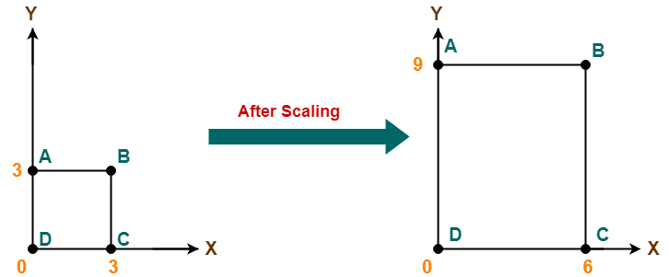

2D Reflection in Computer Graphics-

- Reflection is a kind of rotation where the angle of rotation is 180 degree.
- The reflected object is always formed on the other side of mirror.
- The size of reflected object is same as the size of original object.

Consider a point object O has to be reflected in a 2D plane.

Let-
- Initial coordinates of the object O = (X_{old}, Y_{old})
- New coordinates of the reflected object O after reflection = (X_{new}, Y_{new})

Reflection On X-Axis:

This reflection is achieved by using the following reflection equations-
- X_{new} = X_{old}
- Y_{new} = -Y_{old}

In Matrix form, the above reflection equations may be represented as-

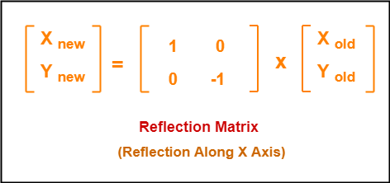

For homogeneous coordinates, the above reflection matrix may be represented as a 3 x 3 matrix as-

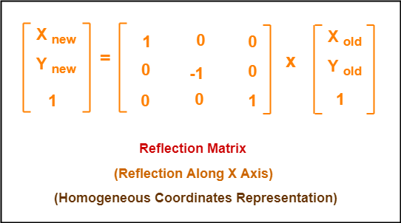

Reflection On Y-Axis:

This reflection is achieved by using the following reflection equations-
- X_{new} = -X_{old}
- Y_{new} = Y_{old}

In Matrix form, the above reflection equations may be represented as-

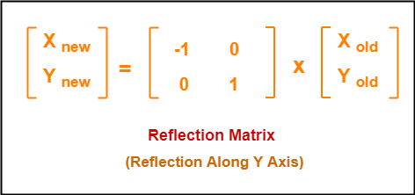

For homogeneous coordinates, the above reflection matrix may be represented as a 3 x 3 matrix as-

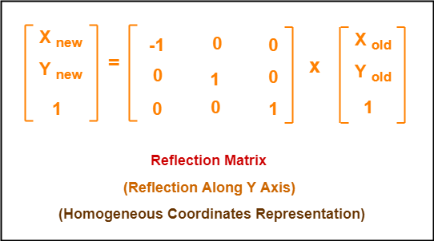

PRACTICE PROBLEMS BASED ON 2D REFLECTION IN COMPUTER GRAPHICS-

Problem-01:

Given a triangle with coordinate points A(3, 4), B(6, 4), C(5, 6). Apply the reflection on the X axis and obtain the new coordinates of the object.

Solution-

Given-
- Old corner coordinates of the triangle = A (3, 4), B(6, 4), C(5, 6)
- Reflection has to be taken on the X axis

For Coordinates A(3, 4)

Let the new coordinates of corner A after reflection = (X_{new}, Y_{new}).

Applying the reflection equations, we have-
- X_{new} = X_{old} = 3
- Y_{new} = -Y_{old} = -4

Thus, New coordinates of corner A after reflection = (3, -4).

For Coordinates B(6, 4)

Let the new coordinates of corner B after reflection = (X_{new}, Y_{new}).

Applying the reflection equations, we have-
- X_{new} = X_{old} = 6
- Y_{new} = -Y_{old} = -4

Thus, New coordinates of corner B after reflection = (6, -4).

For Coordinates C(5, 6)

Let the new coordinates of corner C after reflection = (X_{new}, Y_{new}).

Applying the reflection equations, we have-
- X_{new} = X_{old} = 5
- Y_{new} = -Y_{old} = -6

Thus, New coordinates of corner C after reflection = (5, -6).

Thus, New coordinates of the triangle after reflection = A (3, -4), B(6, -4), C(5, -6).

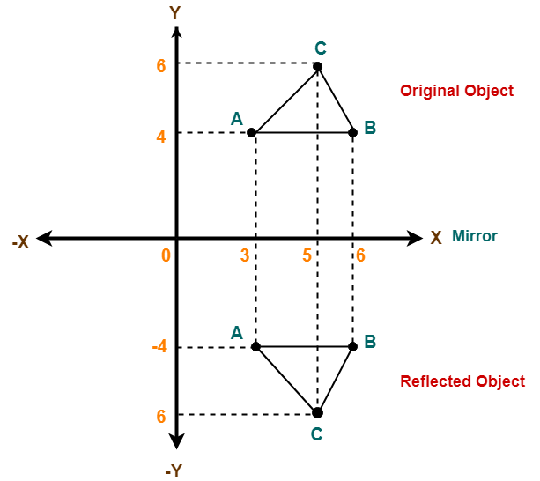

Problem-02:

Given a triangle with coordinate points A(3, 4), B(6, 4), C(5, 6). Apply the reflection on the Y axis and obtain the new coordinates of the object.

Solution-

Given-
- Old corner coordinates of the triangle = A (3, 4), B(6, 4), C(5, 6)
- Reflection has to be taken on the Y axis

For Coordinates A(3, 4)

Let the new coordinates of corner A after reflection = (X_{new}, Y_{new}).

Applying the reflection equations, we have-
- X_{new} = -X_{old} = -3
- Y_{new} = Y_{old} = 4

Thus, New coordinates of corner A after reflection = (-3, 4).

For Coordinates B(6, 4)

Let the new coordinates of corner B after reflection = (X_{new}, Y_{new}).

Applying the reflection equations, we have-
- X_{new} = -X_{old} = -6
- Y_{new} = Y_{old} = 4

Thus, New coordinates of corner B after reflection = (-6, 4).

For Coordinates C(5, 6)

Let the new coordinates of corner C after reflection = (X_{new}, Y_{new}).

Applying the reflection equations, we have-
- X_{new} = -X_{old} = -5
- Y_{new} = Y_{old} = 6

Thus, New coordinates of corner C after reflection = (-5, 6).

Thus, New coordinates of the triangle after reflection = A (-3, 4), B(-6, 4), C(-5, 6).

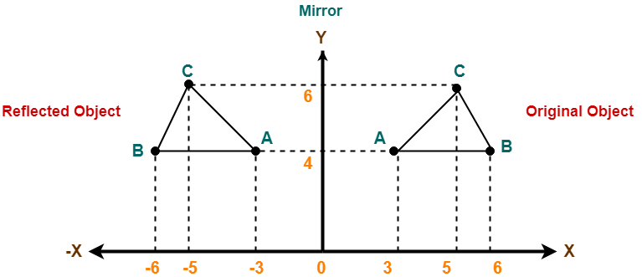

2D Shearing in Computer Graphics-

In Computer graphics,
2D Shearing is an ideal technique to change the shape of an existing object in a two dimensional plane.

In a two dimensional plane, the object size can be changed along X direction as well as Y direction.
So, there are two versions of shearing-

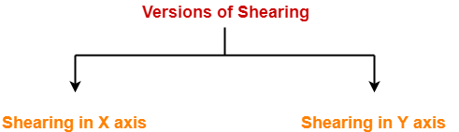

- Shearing in X direction
- Shearing in Y direction

Consider a point object O has to be sheared in a 2D plane.

Let-
- Initial coordinates of the object O = (X_{old}, Y_{old})
- Shearing parameter towards X direction = Sh_{x}
- Shearing parameter towards Y direction = Sh_{y}
- New coordinates of the object O after shearing = (X_{new}, Y_{new})

Shearing in X Axis-

Shearing in X axis is achieved by using the following shearing equations-
- X_{new} = X_{old} + Sh_{x} x Y_{old}
- Y_{new} = Y_{old}

In Matrix form, the above shearing equations may be represented as-

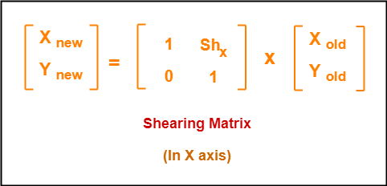

For homogeneous coordinates, the above shearing matrix may be represented as a 3 x 3 matrix as-

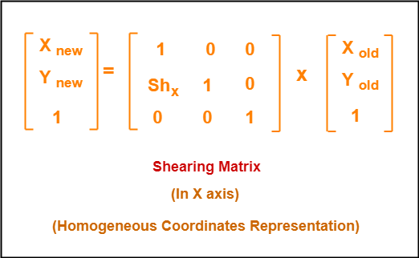

Shearing in Y Axis-

Shearing in Y axis is achieved by using the following shearing equations-
- X_{new} = X_{old}
- Y_{new} = Y_{old} + Sh_{y} x X_{old}

In Matrix form, the above shearing equations may be represented as-

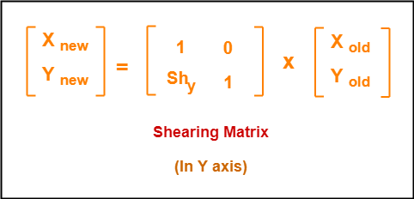

For homogeneous coordinates, the above shearing matrix may be represented as a 3 x 3 matrix as-

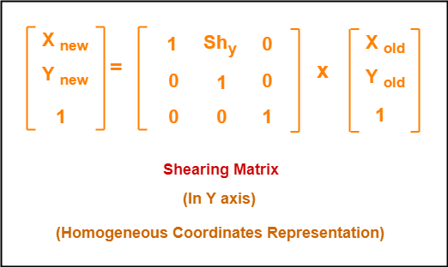

PRACTICE PROBLEMS BASED ON 2D SHEARING IN COMPUTER GRAPHICS-

Problem-01:

Given a triangle with points (1, 1), (0, 0) and (1, 0). Apply shear parameter 2 on X axis and 2 on Y axis and find out the new coordinates of the object.

Solution-

Given-
- Old corner coordinates of the triangle = A (1, 1), B(0, 0), C(1, 0)
- Shearing parameter towards X direction (Sh_{x}) = 2
- Shearing parameter towards Y direction (Sh_{y}) = 2

Shearing in X Axis-

For Coordinates A(1, 1)

Let the new coordinates of corner A after shearing = (X_{new}, Y_{new}).

Applying the shearing equations, we have-
- X_{new} = X_{old} + Sh_{x} x Y_{old} = 1 + 2 x 1 = 3
- Y_{new} = Y_{old} = 1

Thus, New coordinates of corner A after shearing = (3, 1).

For Coordinates B(0, 0)

Let the new coordinates of corner B after shearing = (X_{new}, Y_{new}).

Applying the shearing equations, we have-
- X_{new} = X_{old} + Sh_{x} x Y_{old} = 0 + 2 x 0 = 0
- Y_{new} = Y_{old} = 0

Thus, New coordinates of corner B after shearing = (0, 0).

For Coordinates C(1, 0)

Let the new coordinates of corner C after shearing = (X_{new}, Y_{new}).

Applying the shearing equations, we have-
- X_{new} = X_{old} + Sh_{x} x Y_{old} = 1 + 2 x 0 = 1
- Y_{new} = Y_{old} = 0

Thus, New coordinates of corner C after shearing = (1, 0).
Thus, New coordinates of the triangle after shearing in X axis = A (3, 1), B(0, 0), C(1, 0).

Shearing in Y Axis-

For Coordinates A(1, 1)

Let the new coordinates of corner A after shearing = (X_{new}, Y_{new}).

Applying the shearing equations, we have-
- X_{new} = X_{old} = 1
- Y_{new} = Y_{old} + Sh_{y} x X_{old} = 1 + 2 x 1 = 3

Thus, New coordinates of corner A after shearing = (1, 3).

For Coordinates B(0, 0)

Let the new coordinates of corner B after shearing = (X_{new}, Y_{new}).

Applying the shearing equations, we have-
- X_{new} = X_{old} = 0
- Y_{new} = Y_{old} + Sh_{y} x X_{old} = 0 + 2 x 0 = 0

Thus, New coordinates of corner B after shearing = (0, 0).

For Coordinates C(1, 0)

Let the new coordinates of corner C after shearing = (X_{new}, Y_{new}).

Applying the shearing equations, we have-
- X_{new} = X_{old} = 1
- Y_{new} = Y_{old} + Sh_{y} x X_{old} = 0 + 2 x 1 = 2

Thus, New coordinates of corner C after shearing = (1, 2).
Thus, New coordinates of the triangle after shearing in Y axis = A (1, 3), B(0, 0), C(1, 2).

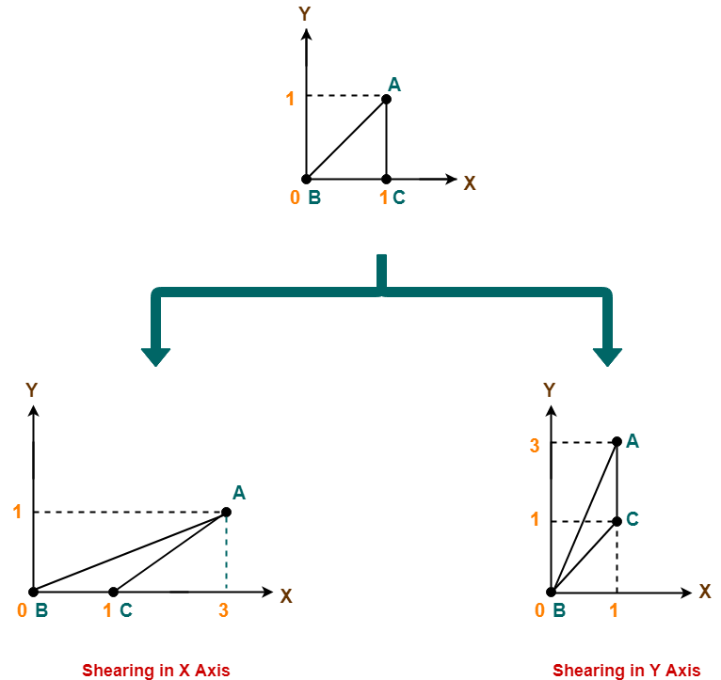

Computer Graphics Homogeneous Coordinates
- Last Updated : 25 Jan, 2023
• Read
• Discuss
Many computer graphics face issues in displaying three-dimensional objects on a two-dimensional screen. We would like to rotate, translate and scale our objects to view them from arbitrary points of view, view as per our perspective. We would like to display our objects in a coordinate system which the system is convenient for us and we can able to reuse them whenever it is required.
Homogeneous coordinates will have some neutral applications in computer graphics, they form the basis for geometry which is used extensively to display three-dimensional objects on two-dimensional image planes. Homogeneous coordinate provides a standard to perform certain standard operations on points in euclidean space means matrix multiplication.
Homogeneous coordinate systems are used in two ways in computer graphics. One of them is by taking an extra value(for example taking the third element in two dimensions and the fourth element in three dimensions) extra element can be any value that will be the divisor of other components which is used occasionally. The restricted form of homogeneous coordinate is also valuable in computer graphics it solves problems in representing and implementing transformations of geometric objects. Most graphics are represented by matrices, and applied for vectors in cartesian form, by taking vectors as column vectors and multiplying them by the transformation’s matrix.
Homogeneous coordinate systems mean expressing each coordinate as a homogeneous coordinate to represent all geometric transformation equations as matrix multiplication. The transformed matrix can be expressed in general matrix form.

a and a’ are column vectors b1 is a 2 by 2 array containing multiplicative factor and b2 is a two-element column matrix containing translation terms.
converting old second coordinate into homogeneous coordinate:

new 3d coordinate is (xh,yh,h), and we can convert the new 3d coordinate into old coordinate by dividing with h.

Now take an example for convert (3,4) into a homogeneous coordinate if h=2.
new coordinate=(3*2,4*2,h)
=(6,8,h)
Converting two-dimensional into three-dimensional vectors, these are used in design and construction applications in these we use translation, rotation, and scaling to transform then and to fit an image in the proper position.

Translation:
It will shift the object from one position to another position, with the given translation in the x or y axis to translate a point from coordinate position (x,y) to another (x,y) we add algebraically the translation distances tx and ty to the original coordinates

Example: a(2,2), b(10,2), c(5,5) translate the triangle with dx=5 dy=6.
a’=a+ t

b’=b +t
c’=c +t

Rotation:
Rotating of an object will be always respective with an angle in the plane. Suppose initial coordinates p(x,y,z), initial angle= sie and rotation angle = theta, then we can perform three types of rotations i.e x-axis, y-axis, & z-axis.
x-axis
x'=x
y'=ycos(theta) - zsin(theta)
z'=ysin(theta) + zcos(theta)

y-axis
x'= zsin(theta) + xcos(theta)
y' = y
z' = zcos(theta) - xsin(theta)

z-axis
x'= xcos(theta) - ysin(theta)
y' = xsin(theta) + ycos(theta)
z'= z

Example : p(1,2,3) theta=90
x'=x=1
y'=ycos(theta)-zsin(theta)
=> 2cos90-3sin90
=> -3
z' = ysin(theta)+zcos(theta)

=> 2sin90+3cos90 => 2

Scaling:
Scaling is the transformation that will change the object size, based on scaling factors sx, sy, sz along the x-axis, y-axis, and z-axis

if s.f=1, object size will not change.
s.f>1, object size enlarges.
s.f<1,object size will reduce.
Scaling of an object with respect to a fixed point (a,b,c)
- scale the object relative to the origin
- translate fixed point to the origin
- translate object back to its original position

Advantages:
Points at infinity can be represented by finite coordinates used extensively in graphics because they perform translation, scaling, and rotation to implement matrix operations in some cases, homogeneous coordinates handle points at infinity.

Disadvantages:
Effect on efficiency requires more space for 4 tuples than 3 4X4 matrix requires more multiplications and additions.

